KCOR: Kirsch Cumulative Outcomes Ratio

Mortality-Neutralized Cohort Comparison Using Generalized Gompertz Dynamics

1. Overview
KCOR (Kirsch Cumulative Outcomes Ratio) is a method for estimating the net mortality impact of an intervention (e.g., vaccination) from retrospective observational data when cohorts differ in baseline mortality and frailty and therefore cannot be validly compared using standard epidemiological techniques.
KCOR addresses a common failure mode in retrospective intervention studies: when cohort selection induces systematic differences in mortality curvature, standard methods confound these structural differences with treatment effects.

2. Why Standard Methods Fail
Vaccinated and unvaccinated cohorts are often not exchangeable:
- Selection bias (static and dynamic Healthy Vaccinee Effect, HVE) creates cohorts with different frailty compositions
- These differences manifest as different hazard slopes (curvature), not merely different hazard levels
- This violates assumptions underlying Cox proportional hazards models, ASMRs, IPTW/probabilistic matching, and 1:1 matching
Even when covariates are balanced, differential frailty depletion over event time breaks proportional hazards.

3. Core Insight of KCOR
Cohorts cannot be compared fairly unless their intrinsic mortality curvature is first neutralized.
Observed mortality differences reflect: 1. Baseline Gompertz mortality
2. Frailty mixing and depletion of susceptibles
3. Selection bias (HVE)
4. Any true intervention effect
KCOR removes (2) and (3) by directly estimating and neutralizing cohort-specific mortality curvature in log-hazard space before comparing cohorts.

4. Cohort Construction
- Cohorts are fixed at enrollment
- Assignment is based on intervention status at enrollment week
- No censoring and no cohort switching (avoids health-seeking bias)
- Analysis proceeds forward in event time

5. Hazard Computation
Let:
- s = event time since cohort enrollment (e.g., weeks since enrollment)
- D(s) = deaths occurring during interval s
- N(s) = number alive at the start of interval s
Hazard is treated as piecewise-constant over weekly intervals.
The discrete-time hazard is computed as:
$$h\left(s\right)=-ln\left(1-\frac{D\left(s\right)}{N\left(s\right)}\right)$$

6. Mortality Model
At the individual level, adult human mortality is well approximated by Gompertz growth:
$$h_{i}\left(s\right)=z_{i}e^{ks}$$
where: - $z_{i}$ is individual frailty - $k$ is the Gompertz log-slope
Population-level deviations arise from frailty mixing and selective depletion.

7. Generalized Gompertz–Frailty Model (Used in KCOR)
Cohorts formed by selection (e.g., vaccination choice or timing) are not well described by gamma frailty. KCOR therefore models cohort-level mortality curvature using the following 4-parameter generalized form:
$$logh\left(s\right)=C+k_{∞}s+\left(k_{0}-k_{∞}\right) τ\left(1-e^{-s/τ}\right)$$
Parameters:
- $C$ : scale constant
- $k_{0}$ : initial cohort log-slope
- $k_{∞}$ : asymptotic Gompertz log-slope
- $τ$ : relaxation time constant
The instantaneous log-slope is:
$$k\left(s\right)=\frac{d}{ds}logh\left(s\right)=k_{∞}+\left(k_{0}-k_{∞}\right)e^{-s/τ}$$
Thus the slope relaxes smoothly from $k_{0}$ at enrollment toward $k_{∞}$ as $s→∞$, capturing depletion and resilience dynamics without assuming gamma frailty.

8. Slope Estimation
- Ages < 80: fit
$$logh\left(s\right)=α+βs$$
- using quantile regression (τ = 0.5), which is robust to transient shocks and outliers
- Ages ≥ 80: fit the generalized model above and estimate $\left(k_{0},k_{∞},τ\right)$

9. Slope / Shape Normalization
KCOR removes cohort-specific mortality curvature by subtracting the fitted shape in log-hazard space. Normalization is performed in hazard space, not cumulative mortality space.

9.1 Linear (Gompertz) case — ages < 80
When cohort mortality is well approximated by a log-linear model:
$$logh\left(s\right)=α+βs$$
the cohort-specific shape is:
$$g\left(s\right)=βs$$
Normalization is:
$$logh_{\text{adj}}\left(s\right)=logh\left(s\right)-βs$$
or equivalently,
$$h_{\text{adj}}\left(s\right)=h\left(s\right)e^{-βs}$$

9.2 Generalized (curved) case — ages ≥ 80
For cohorts modeled using the generalized form, the cohort-specific shape is:
$$g\left(s\right)=k_{∞}s+\left(k_{0}-k_{∞}\right) τ\left(1-e^{-s/τ}\right)$$
Shape normalization subtracts this entire function:
$$logh_{\text{adj}}\left(s\right)=logh\left(s\right)-g\left(s\right)$$
or equivalently,
$$h_{\text{adj}}\left(s\right)=h\left(s\right)exp​\left[-k_{∞}s-\left(k_{0}-k_{∞}\right) τ\left(1-e^{-s/τ}\right)\right]$$
The scale parameter $C$ is absorbed by later baseline normalization.

10. KCOR Definition
For cohorts $A$ and $B$:
KCORt=s≤t​hadj,Ass≤t​hadj,Bs
Interpretation:
- KCOR ≈ 1 : mortality equivalence
- KCOR > 1 : excess mortality in numerator cohort
- KCOR < 1 : mortality benefit in numerator cohort

11. Stabilization Rules
- KCOR is normalized to 1 using weeks 3–6 post-enrollment
- Weeks 1–2 are excluded to reduce dynamic HVE and acute deferral effects
The 3–6 week window empirically provides stable anchoring while avoiding immediate post-enrollment artifacts.

12. Validation
- Negative controls: KCOR remains flat under null, including extreme pathological selection scenarios
- Positive controls: transient wave-associated mortality bursts produce detectable departures from unity

13. Interpretation
KCOR estimates the net cumulative mortality impact after removing cohort mortality structure in log-hazard space.

14. Confidence Intervals
Confidence intervals are computed via Monte Carlo resampling with replacement, incorporating uncertainty from: - stochastic death counts within cohorts - slope / shape estimation error

15. Summary
KCOR enables valid mortality comparisons in retrospective data when traditional approaches are confounded by selection-induced hazard curvature, by explicitly modeling and removing cohort-specific mortality structure before comparing cumulative hazards.

16. Schematic Illustration (Conceptual)
A useful way to visualize KCOR is in log-hazard space:
- Before normalization, cohorts exhibit different slopes and curvature due to selection and frailty depletion.
- Shape normalization removes these cohort-specific trends, flattening both curves under the null.
- Any remaining divergence after normalization represents excess mortality attributable to the intervention.
Such a schematic typically shows: 1. Two diverging log-hazard curves (pre-normalization) 2. Both curves flattened and aligned (post-normalization) 3. Residual separation only when a true effect exists
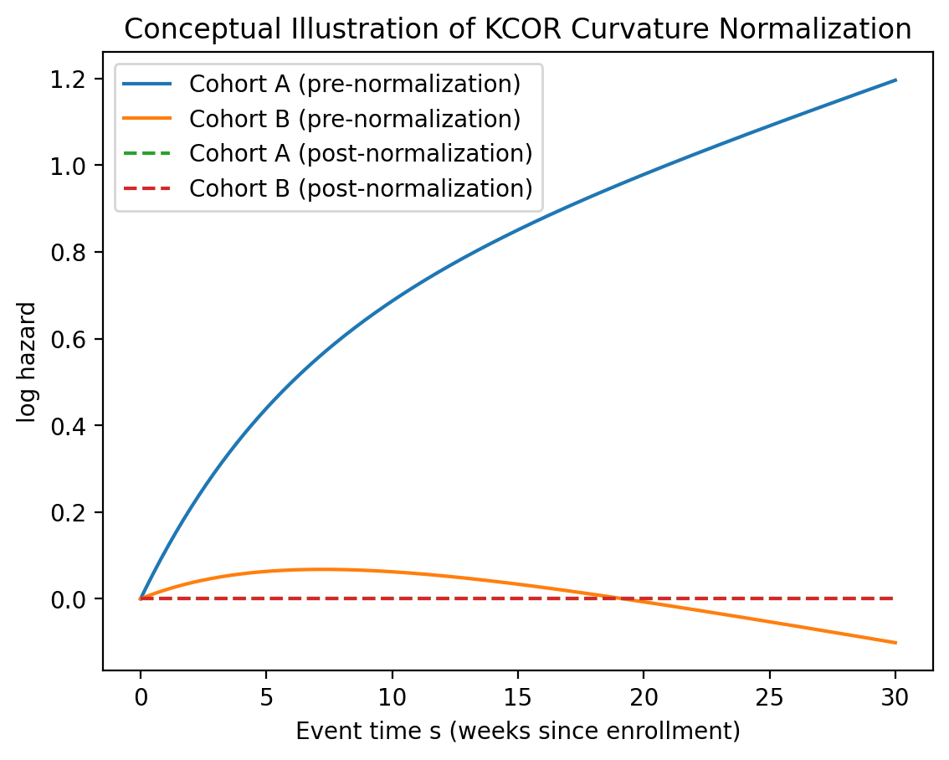

17. Why Cox / IPTW Fail Here (Explicit Contrast)
Cox proportional hazards and IPTW-based methods assume that, after adjustment, hazards differ only by a time-invariant multiplicative factor.
In the presence of selection-induced curvature:
- Hazards are non-proportional by construction
- Matching on covariates cannot equalize frailty depletion dynamics
- IPTW reweights levels but does not remove time-varying slope differences
As a result, Cox/IPTW interpret curvature differences as treatment effects, producing biased estimates. KCOR avoids this by removing curvature prior to comparison.

18. When KCOR Should NOT Be Used
KCOR is not appropriate when:
- Cohorts are already randomized or exchangeable (e.g., large RCTs)
- Event counts are too sparse to estimate hazard slopes reliably
- Follow-up is too short to observe mortality curvature
- Outcomes are not well modeled by hazard-based processes
In such cases, simpler estimators may be preferable.

Appendix A: Derivation Sketch
Frailty depletion and selection alter the effective cohort frailty distribution over event time, inducing curvature in $logh\left(s\right)$. Allowing the cohort log-slope to relax exponentially from an initial value $k_{0}$ to an asymptotic value $k_{∞}$ yields the generalized model above without requiring gamma frailty assumptions.
For example, if you construct a pathological cohort of 5 different frailty levels as noted in the figure, the 4-parameter form fits this nearly exactly:
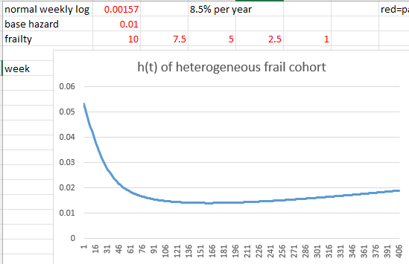

Appendix B: Reviewer Framing
- KCOR does not assume proportional hazards; it estimates and removes cohort-specific hazard curvature
- Normalization occurs in log-hazard space, not cumulative mortality space
- The generalized model preserves Gompertz asymptotics while capturing depletion/selection curvature
- Negative controls demonstrate KCOR does not generate spurious signals under extreme selection
- The method is generic: it applies to any cohort comparison with selection-induced curvature

